Accelerating AWS Migration Through Agile Transformation

**Agenda :**

* **Sysco Corporation Overview**
* **Journey to cloud before Agile**
* **Using agile to accelerate cloud migration(and vice versa)**
* **Future Outlook:**

Good things come from sysco’s cloud

**Sysco Corporation Overview :**

* Sysco, founded in 1969, is the global reader in selling,marketing, and distributing food products to restaurants, healthcare and educational facilities, lodging establishment, and other customers around the world.

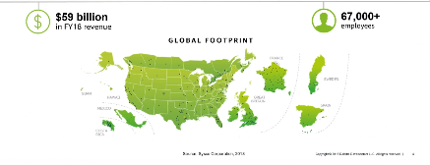

**Initial Journey to cloud :**

The journey to cloud began as an effort to improve sysco’s master data management platform before evolving into exploring how to change the way sysco operates to fulfil the infrastructure’s potential.

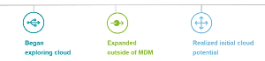

Built cloud solution to After Successfully After Scaling the

Accelerate data Implementing cloud in cloud infrastructure

Integration process the MDM, sysco explored targeted areas,

MDM platform additional cloud demand grew

opportunities throughout the

organization

**Benefits of cloud migration before agile** :

* Reduced time to delivery
* Upskilled employees
* Decreased physical data center footprint
* Broke down silos
* Empowered application teams to innovate
* Improved qualities of deliverables

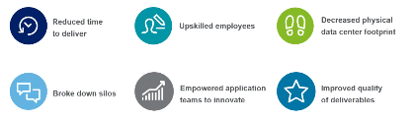

**But … we reached an impasse :**

While sysco’s migration to the cloud provided great initial benefits, there came a point where the only way to continue to move forward was to change the way the organization operated.

* Everyone wanted cloud services
* Reverted to old processes to get things done
* Limited people with cloud skillset to meet demand
* Manual processes were not being automated fast enough
* Determined agile was the solution
* Explored different operating models
* Looked at other industry leaders

**Next step in the cloud journey :**

In order to address the challenges experienced in scaling cloud, sysco and Deloitte working together to explore the idea of implementing an agile operating model that would help deliver these service quickly**.**



Implemented agile as next step as the journey

Transformed to an agile operating model to help unlock additional potential of cloud.

**Agile transformation goals :**

Sysco realized that implementing an agile model allowed the organization to realize the additional benefits of scaling cloud quickly throughout the organization.

**Agile** : Enable high-value improvements in the areas that matter most

**Strategic :** Prepare staff and expand the pool of future IT services

**Smart :** preserve what work, retaining current functionality and sysco specific business logic

**Safe :** Reduce organizational risk minimizing disruption to user and technical communications

**Flexible:** Allow for taking advantage of opportunities down the road

**Quick :** Provide new system capabilities sooner than rip-replace-efforts

Capable : Improve technical system capabilities, using industry-leading third-party products

